Which version of my publication should I deposit to espace?
Navigating publisher polices to verify author’s rights to self-archive in an institutional repository can be complex and time consuming.
Simplify the deposit process by uploading the accepted version of your research when you claim your publication in Elements.
The Curtin Library espace team checks the publisher’s self-archiving policies to ensure compliance with copyright, including any embargo periods, before making the full text publicly available.
Simple.

So why can the espace team only make a small percentage of Curtin Researcher’s uploaded files publicly available in espace?
Frequently, Curtin Researchers mistakenly upload the published PDF version. Generally, the published PDF version can only be displayed in espace if the author has retained copyright or published their research under a Creative Commons licence.
So, if you are unsure of your copyright obligations, please deposit the accepted version of your research when you claim your publication in Elements.

What is the difference between the accepted version and the published version of my research?
The accepted version, also known as the author’s accepted manuscript, is the version that has undergone peer review and been accepted for publication but has not yet been copy-edited and formatted for publication. Generally, these are in the form of a Word document rather than a PDF.

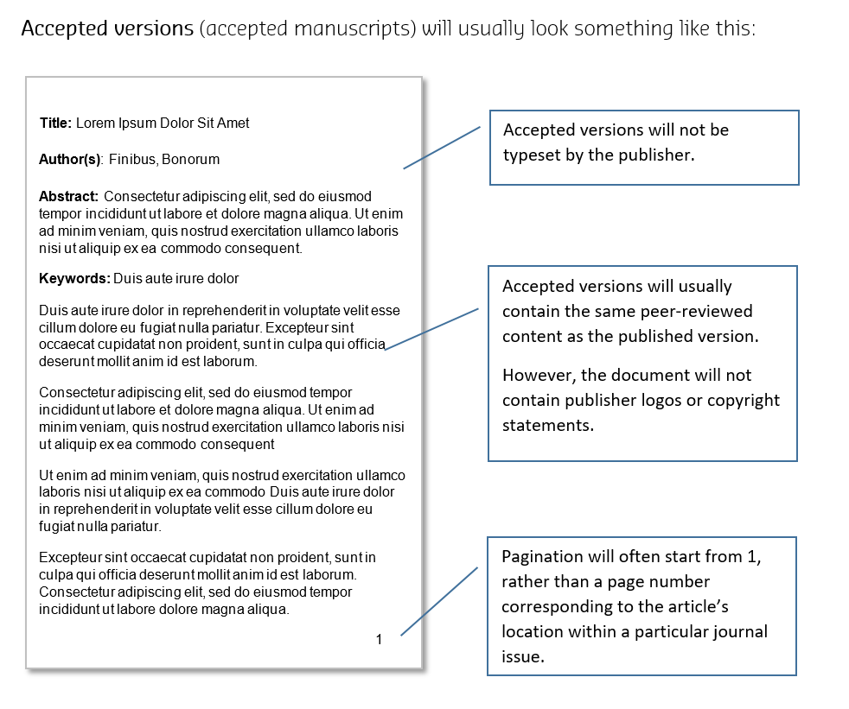

Below are some examples of accepted versions versus published PDFs.

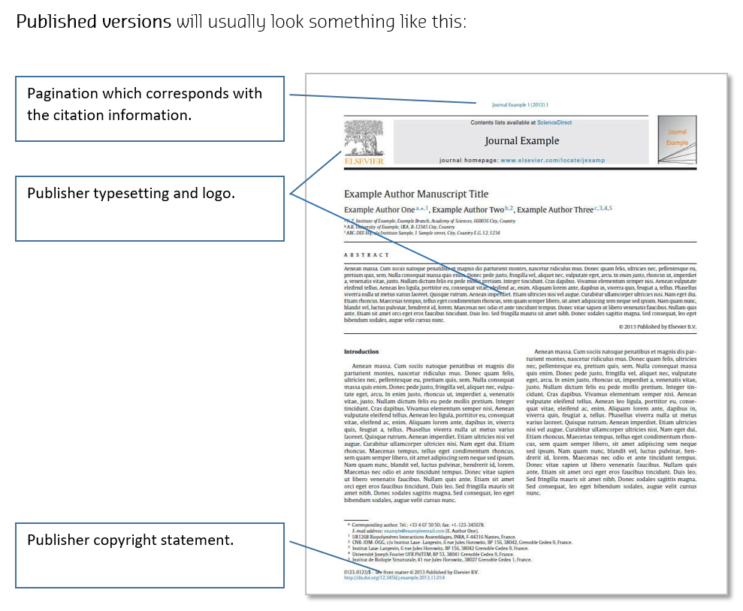

Below are some examples of accepted versions versus published PDFs.

